**Welcome to Brookfield Surgery Patient Newsletter**

**Tel:** ***01925 756969 Website:*** [***www.brookfieldsurgery.co.uk/***](http://www.brookfieldsurgery.co.uk/)

***May 24***

**Our Team**

**Doctor Aparna Rao**

**Doctor Priya Sumra**

**Doctor Matthew Leech**

**Doctor Emma Lynch**

**Doctor Sarah Williams**

**Doctor Nandini Biswas**

**Doctor Daria Mudrak**

**Carole Geggie Advanced Nurse Practitioner**

**Debbie Taylor Practice Manager**

**Beverley Stirrup Deputy Practice Manager**

**Sharron Worral Reception Manager**

**Say Hello**

We are delighted to welcome our new GP Registrars, Dr Darlia Idris.



*We are pleased to announce Doctor Nandini Biswas and Doctor Daria Mudrak have now Brookfield Surgery as Salaried GPs.*

*Doctor Nandini Biswas works Monday & Thursday / Doctor Daria Mudrak works Monday*

**Appointments**

### We offer face to face, telephone and online consultations.

### Patchs is available for administrative requests and non-urgent minor problems (subject to availability). Your Patchs will be assessed within 2 working days and if necessary, an appointment will be made via the telephone or face to face up to two weeks ahead.

Before you submit an patchs consider the alternatives. The pharmacist at your local chemist is highly trained in offering a wide range of services and may be able to give you the help you need, so you won’t have to spend time waiting for an appointment

You may be offered an appointment with one of our clinicians at one of our attached network clinics. This service gives patients quick access to a clinician.



The eConsult service is continuing to be embedded into how patients access health care services and will be responded to by the end of the next working day. You can submit an eConsult Monday to Friday between 8:00am and 12 noon only (unless all appointments have been allocated for that day). If you have an urgent issue, please ring the practice (in hours) or NHS 111 (out of hours). Following clinical triage, we may allocate you a telephone appointment slot or face to face appointment up to 4 weeks in advance of your e-consultation.

e-Consult can be accessed at our website www.brookfieldsurgery.co.uk

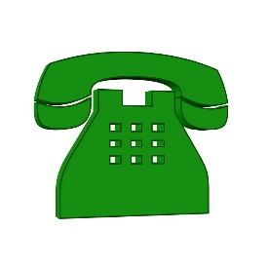

**Signposting patients to healthcare services**

We have a large group of clinicians working together providing health care appointments. These include:

* First contact Physio
* Mental Health Practitioner
* Local Pharmacist
* Care Coordinator
* Advanced Nurse Practitioner
* Social Prescriber
* Practice Nurse
* Clinical Pharmacist
* Community Paramedic

It may be necessary for one of the above clinicians to review you.

**NHS HEALTH CHECKS**

The [NHS Health Check](http://www.nhs.uk/Conditions/nhs-health-check/Pages/What-is-an-NHS-Health-Check-new.aspx) is a health check-up for adults in England aged 40-74. It's designed to [spot early signs](http://www.nhs.uk/Conditions/nhs-health-check/Pages/What-happens-at-an-NHS-Health-Check-new.aspx) of stroke, kidney disease, heart disease, type 2 diabetes or dementia. As we get older, we have a higher risk of developing one of these conditions. An NHS Health Check helps find ways to lower this risk.

[How do I get an NHS Health Check?](http://www.nhs.uk/Conditions/nhs-health-check/Pages/How-do-I-get-an-NHS-Health-Check.aspx)

If you're in the 40-74 age groups without a pre-existing condition, we will invite you for your free NHS Health Check every five years. Speak to one of our receptionists for further information.

[How can I improve my test results?](http://www.nhs.uk/Conditions/nhs-health-check/Pages/your-NHS-Health-Check-results-and-action-plan.aspx)

Once you've had your NHS Health Check, your healthcare professional will [discuss your results](http://www.nhs.uk/Conditions/nhs-health-check/Pages/your-NHS-Health-Check-results-and-action-plan.aspx) with you. You'll be given advice to help you lower your risk of a stroke, kidney disease, heart disease, diabetes or dementia, and maintain or improve your health. But you don't have to wait until then to make healthy changes.



**COVID Spring Booster Vaccinations** COVID-19 is more serious in older people and in people with certain underlying health conditions. For these reasons, people aged 75 years and over, those in care homes, and those aged 5 years and over with a weakened immune system are being offered a spring booster of COVID-19 vaccine. The Practice will notify you if you are eligible to book an appointment.

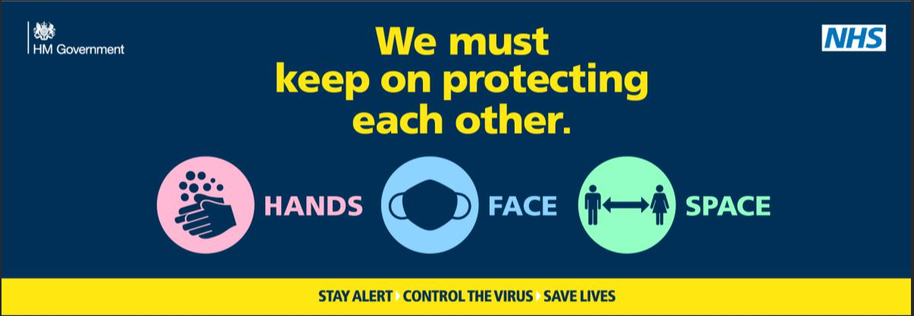

**Patient Participation Group**

The patient participation Group (PPG) is a very informal feedback session. We will always welcome new members, or comments, so if you are a patient of Brookfield Surgery and would like some more information please ask at Reception.

Next PPG meeting will be held in July 25 - TBC



Annual Health Checks

If you have any of the following **long term health conditions** you will be contacted to arrange an annual review with one of our Practice Nurses

• ***Asthma*** 

• ***Diabetes***

• ***High blood pressure (hypertension)***

• ***Heart disease***

*•* ***Stroke***

*•* ***Chronic airways disease (COPD)***

**Friends and Family** When you visit our GP Surgery you will be able to complete a Friends & Family short form, stating whether or not you would recommend us to your friends and family if they need similar care or treatment.  Your answers will be anonymous and can be completed at the surgery, please post feedback in the box provided, which are located in our waiting area. It is important to the practices that we review and listen to your feedback.

|  |  |  |  |  |  |  |
| --- | --- | --- | --- | --- | --- | --- |
| **April 24** | **Extremely Likely** | **Likely** | **Neither likely nor unlikely** | **Unlikely** | **Extremely unlikely** | **Don’t know** |
|  | 15 | 0 | 0 | 3 | o | 0 |
| Responses | Friends and Family Comments  Extremely Likely  Never had an issue  Having been coming here for over 30 years  Kerry the nurse was excellent  Two extremely helpful receptionists  Excellent Care and Service  Both receptionist and Doctor listened to my concerns  Fabulous receptionists and secretaries  Excellent Comprehensive care given by GPs  Reception staff always helpful  Unlikely  Have to wait 1 month for a blood test  Very abrupt staff  The bureaucracy is rubbish – waste of time and energy | | | | | |
| Brookfield Surgery – Feedback for patients | Many thanks for all your comments  All your comments will be discussed in our clinical meeting.  Our reception team always try to ensure patients are treated respectively and with care and consideration.  We do not unfortunately have the capacity to accommodate all bloods tests at the practice. We unfortunately do have a wait when our phlebotomist is on holiday. We apologise if this causes frustration for our patients.  Many thanks | | | | | |



Aged 70-79 Book your Shingles Vaccination appointment today

[Shingles](https://www.nhs.uk/conditions/shingles/) can be very painful and uncomfortable. Some people are left with pain lasting for years after the initial rash has healed. Shingles can also be fatal for around 1 in 1,000 over-70s who develop it.

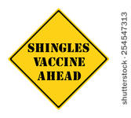

It's fine to have the shingles vaccine if you've already had shingles. The shingles vaccine works very well in people who have had shingles before, and it will boost your immunity against further shingles attacks. Your GP will tell you how long to wait after you recover from shingles before having the shingles vaccine. This may be up to 1 year.

**Who can have the shingles vaccination?**

You're eligible for the shingles vaccine if you are aged 70 to 79.

The shingles vaccine is not available on the NHS to anyone aged 80 or over because it seems to be less effective in this age group.

***Have you had a bowel screening kit sent to you – Have you responded ?? 60 to 74 years***

|  |  |
| --- | --- |
| **If you’re taking care of number 1…check your number 2’s!** | |
| If you were recently sent a bowel cancer screening kit to test your bowel motion (faeces/ poo) but haven’t sent it back yet.  I would like to remind and encourage you to complete and send back your screening kit. | *The Bowel Cancer screening kit contains testing kit, sample sticks, leaflet & prepaid envelope* |

The signs and symptoms of bowel cancer often go unnoticed until the disease is already well developed, but **if caught early enough 90% of bowel cancers can be successfully treated.**

If you would like to discuss anything further please call the NHS Bowel Cancer Screening Programme freephone helpline on **0800 707 6060** (Calls are free from UK landlines).

As your GP, I would like to encourage you to complete your bowel cancer screening kit as soon as possible. If you no longer have your kit, please call **0800 707 6060** to request a new kit. Once you have received the screening kit, if you have any questions please call **0800 707 6060**.